2026 Ice Racing Sponsor Info Sheet

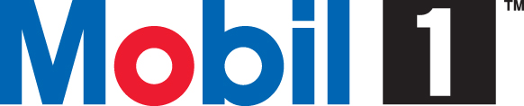
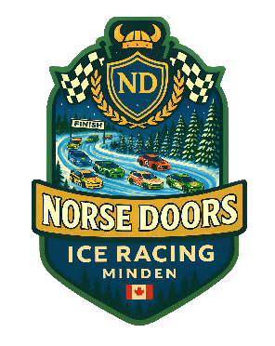
Norse Doors
Family-owned garage door repair and installation company. Over 15 years of experience. We service Kawartha lakes and surrounding areas. We also work in the GTA area.
https://www.norsedoors.ca
norsedoors@gmail.com

Mobile 1
Mobil 1 is the world’s leading synthetic motor oil brand. Our motor oils are tailored to engine needs and driving styles – from performance machines to those cars we keep driving for over 120,000 kilometers.
https://www.mobil.ca/en-ca/lubricants


Syntheia AI
Natural voice AI for business call automation that enhance every customer journey.
https://www.syntheia.ai
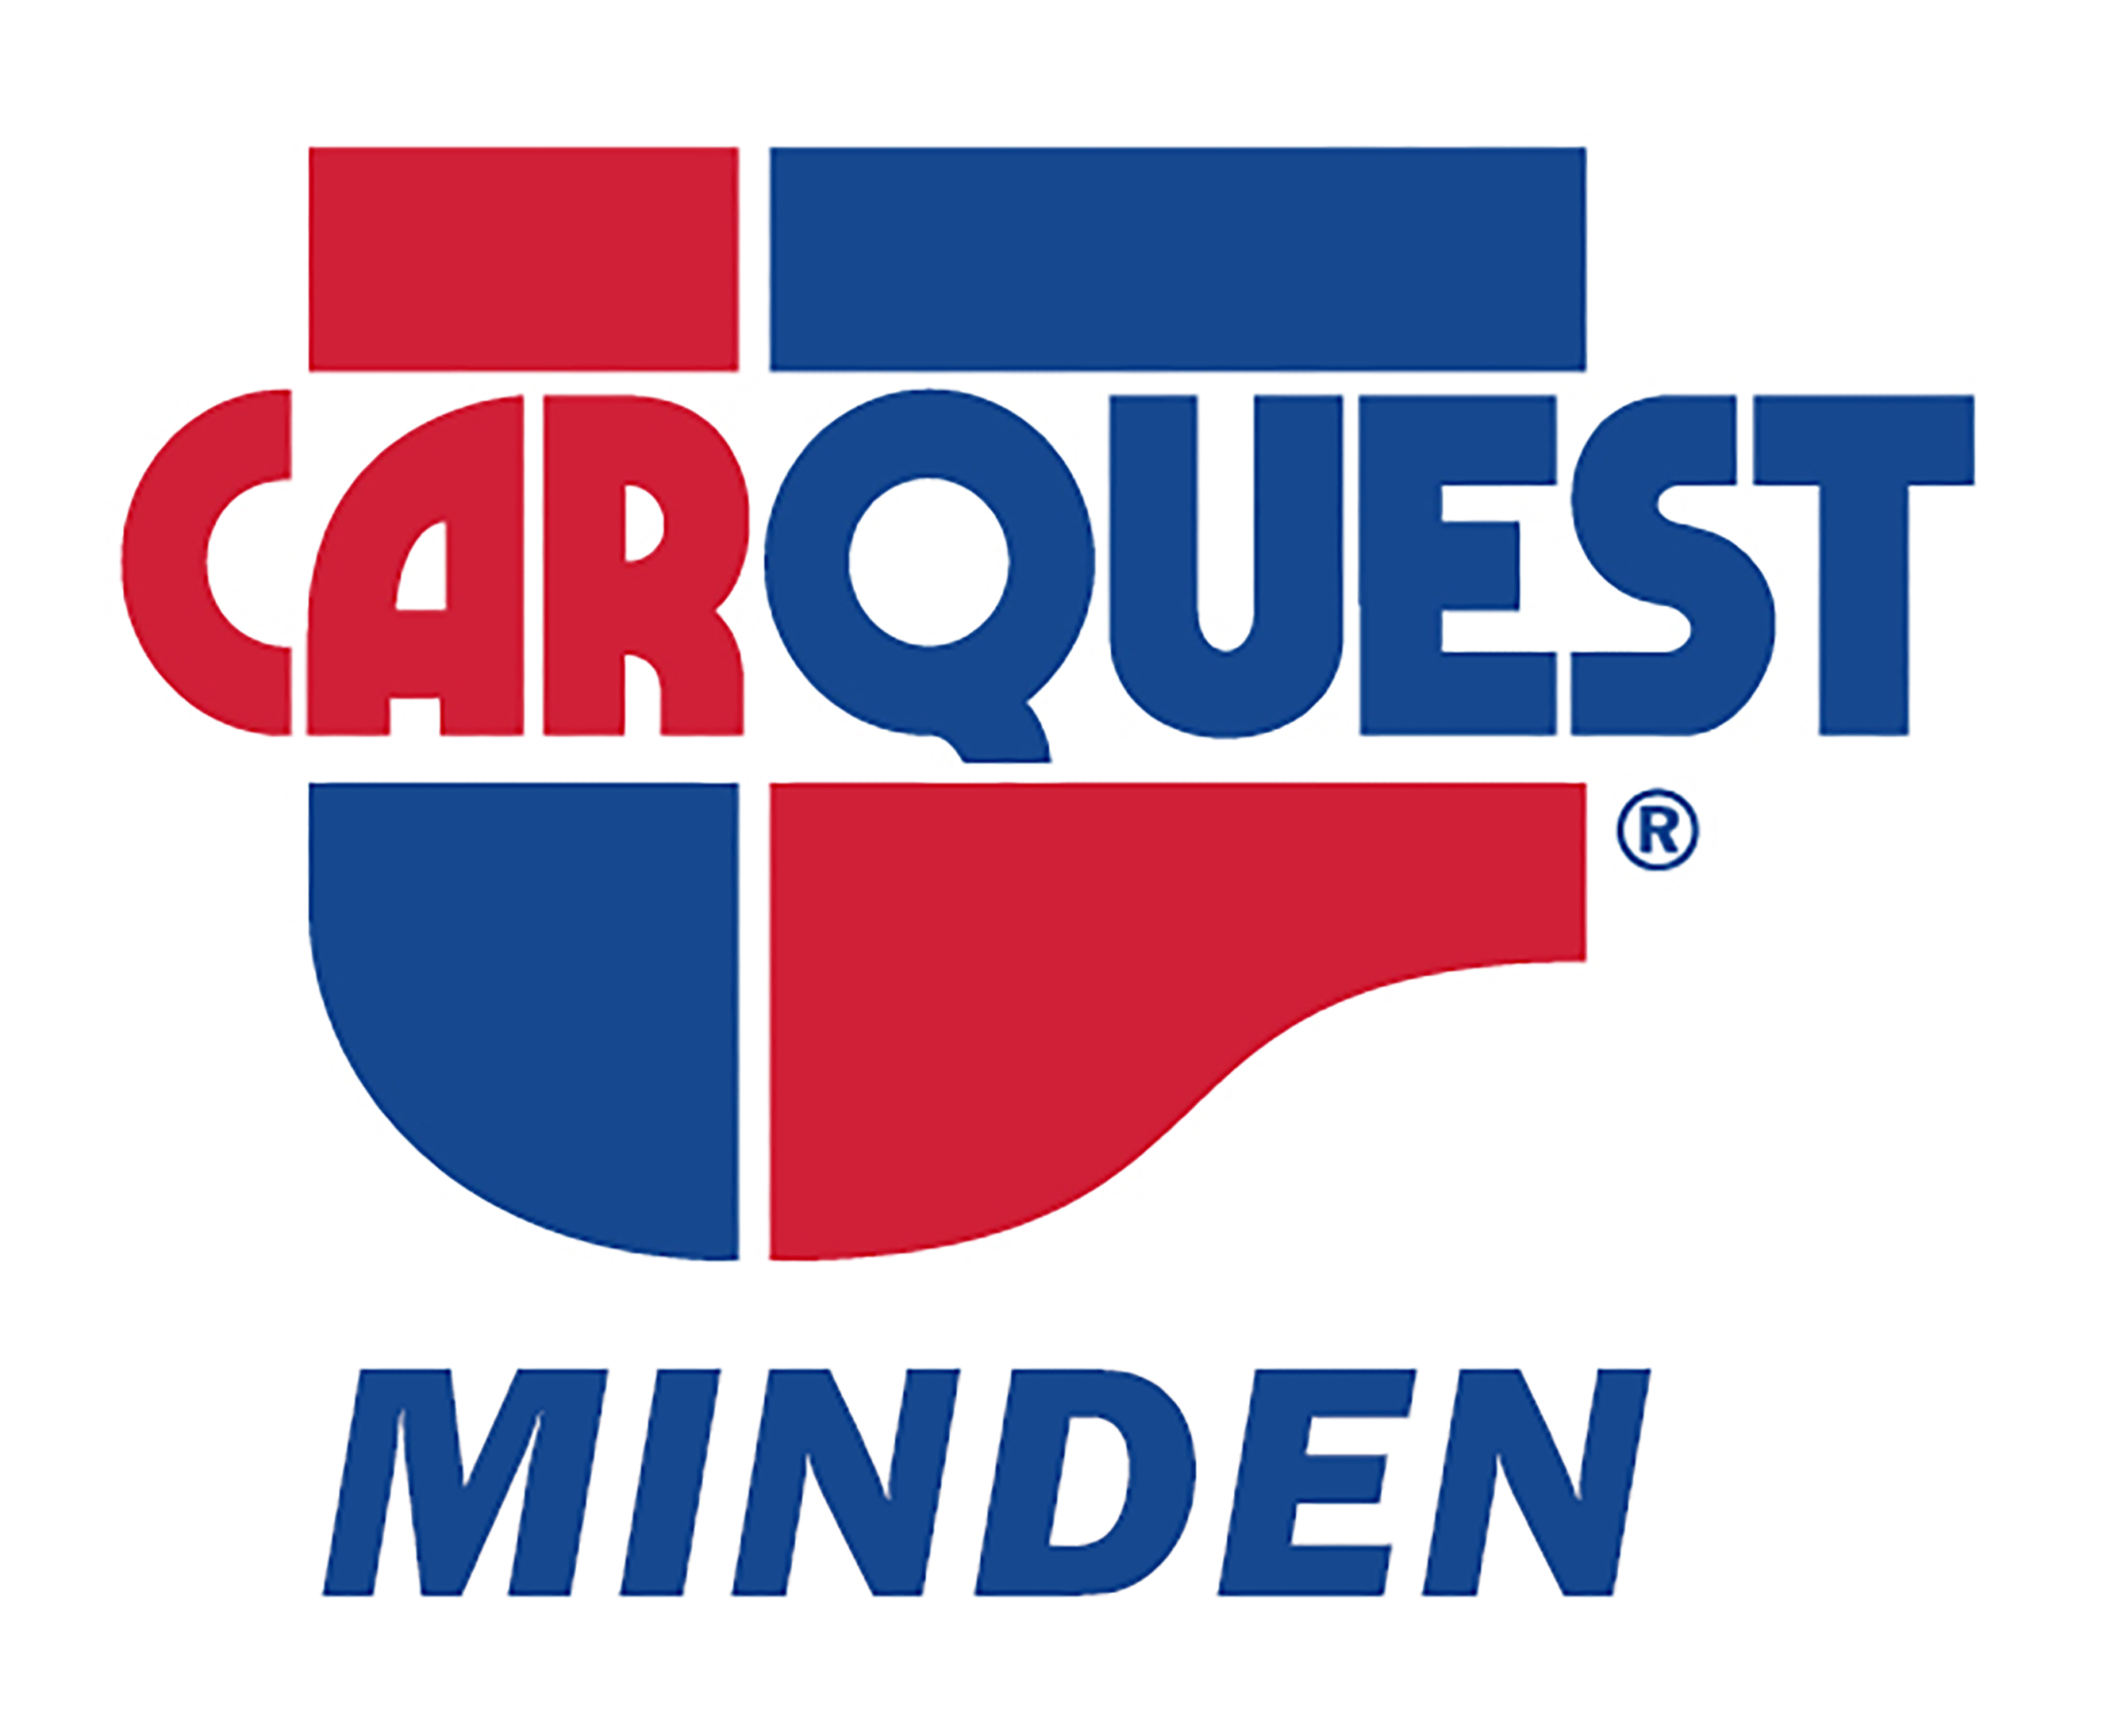
Carquest Minden
Locally owned and operated auto parts experts.
https://www.carquestminden.com
705-286-1011

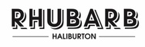
Rhubarb Restaurant – Carnarvon
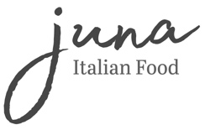
Juna Restaurant – Haliburton downtown
Locally owned and operated, they refuse to compromise on quality. Amazing dishes are created with fresh ingredients from local farmers and area producers!
https://rhubarbhali.com/
https://www.junahaliburton.com

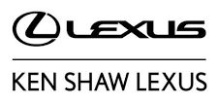
Ken Shaw Lexus
Lexus and Toyota, proudly serving Toronto for over 60 years.
https://www.kenshawlexus.com
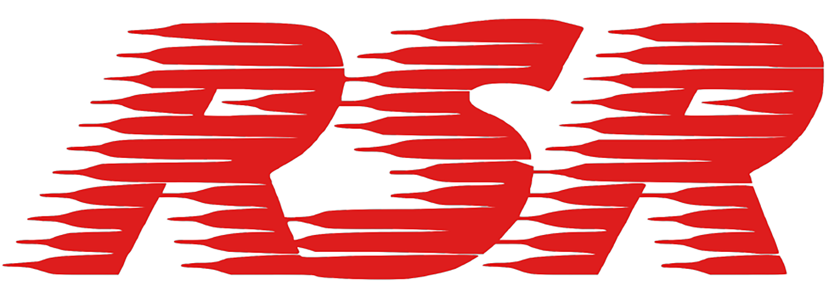
Rashleigh, Shaw, Robson Racing
Involved and supporting Ice Racing in Ontario since the early 70’s.

