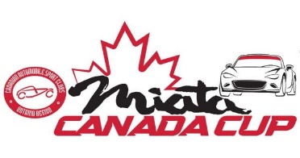
Welcome to the 1st race of the Miata Canada Cup, the 2024 SMP Cup at Shannonville Motorsport Park (SMP)
Dates: Friday May 31st to Sunday June 2nd
Friday May 31st Test Day, Saturday June 1st Qualifying & Race 1, Sunday June 2nd Races 2 & 3
Entry Requirements & Registration:
**All participants must have a minimum CASC class B road race license. Info on how to get your liscence can be found here.
**All participants cars must meet the rules as laid out by CASC. Rules for the Miata Canada Cup can be found here.
**Participants in the Miata Canada Cup may win prize money! To be eligible for prize money available from Mazda Canada all participants must register for the Miata Canada Cup via Motorsport Reg https://www.motorsportreg.com and participate in 3 of 4 events. You can register for the Miata Canada Cup here.
**All participants must register for each event individually via Motorsport Reg. Cost for this event is $675+$2 booking fee. You can register for the 2024 SMP Cup here. Please note that a late entry fee will be in effect as of May 23, 2024.
**All participants must register for the Friday test day directly with the track should they wish to participate. Cost will be $300 + HST. You can register for Friday test day here.
**Please note there is no onsite fuel available at SMP

Waivers:
EVERYONE attending the event (including non-participant guests) must have a CASC-OR Road Race Annual Waiver in place. If you have not previously completed this waiver, please do so before arriving at the track. Here is the link: Annual Waivers.

